Institute for Family Advocacy and Leadership Development


PO Box 502
Epping NSW 1710

305/16-18 Cambridge Street
Epping NSW 2121

Phone (02) 9869 0866
Facsimile: (02) 9869 0722
Email: familyadvocacy@family-advocacy.com

 | File number: | 11243
Author: | Inclusion Works
Title: | Stories of Community Inclusion: helping build better communities through the inclusion of people with disability.
Original Source: | Inclusion works web site - www.inclusionworks.org.au
Publication date: | 2010
Publisher information: | www.inclusionworks.org.au
Abstract:
These stories of inclusion provide examples of people with disability being supported to pursue interests in their community. Although the stories refer to a community development worker assisting in this process, the person facilitating the connection could equally be someone who is a family member or friend of the person with disability. It may be helpful to read these stories in conjunction with The Art of Asking by Ric Thompson (File number: 11146)

Haydn's Story
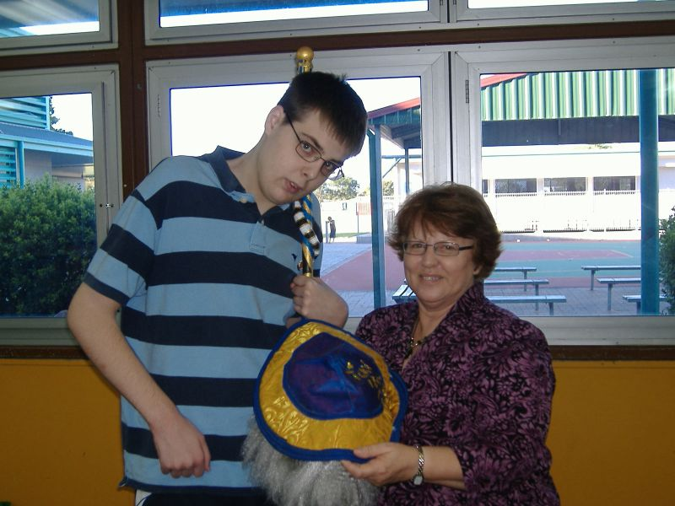
Haydn has been pursuing an acting career for only a short time but his passion for theatre has been evident throughout the course of his life.

Haydn first realised that he wanted to become an actor after seeing Tropic Sun Theatre’s performance of Henry IV. Since then Haydn has realised his passion for Shakespearian plays and looks forward to one day being able to perform it with Tropic Sun Theatre Company.

Haydn was introduced to Inclusion Works towards the end of 2009. Since then Haydn has realised his passion for Shakespearian plays and looks forward to one day being able to perform it with Tropic Sun Theatre Company.
Haydn was introduced to Inclusion Works towards the end of 2009. Since beginning to work alongside him, Haydn has become a very confident young man who is finding his own paths for further development in acting. He recently involved himself with Props Youth Theatre where he landed one of the lead roles. When Haydn started with Props he was immediately recognised as being a larger than life, passionate, ambitious actor and was welcomed with a warm smile and immediate inclusion into the drama activities. He has developed a good repour with his Director Karen Vane and enjoys spending his Sundays rehearsing his first ever play that is set to start this December.

“Haydn shows great leadership through his preparation of his character and through his excitement and enthusiasm for the part he is playing. I believe that he is set to give a great performance when the show opens in December.” – Karen Vane.

In 2010 Haydn hopes to join Townsville Little Theatre where he can further develop his reputation within the theatrical community. Haydn endeavours to undergo further training with vocal coaches as well as attending university to study creative arts. Haydn plans to further his career quickly and effectively over the next few years and looks forward to propelling himself on into his chosen acting career.

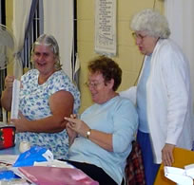
Lesley's Story
A gentle lady with an infectious smile is creating beautiful pieces of needlework while at the same time having a “chin wag” with the Mundingburra branch of the Country Women’s Association.
Lesley is a familiar face at the Monday night CWA craft group and is warmly welcomed. Esme Squires, Divisional Vice President of the CWA comments that “Lesley loves the social aspect and really enjoys herself”.

Through Lesley’s membership, the CWA has acquired a dedicated team member whose personality mirrors the association’ s motto of caring, providing and nurturing. Previous to Lesley joining the CWA, her social involvement within the community was minimal. Through the assistance of Stacey, a Community Development Worker from Inclusion Works and with the support of the CWA, Lesley offers constantly her unique gifts, talents and contributions to help make the Mundingburra branch of the Country Women’s Association a better association.
Lesley assists the CWA through the donation of her fabulous cooking for raffles. She is an active member in their monthly meetings as well as demonstrating what it’s all about – having fun and meeting new people at the same time.

Aaron's Story
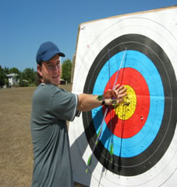
Aaron is not loud or boisterous. He has a quiet nature. This resulted in Aaron living a solitary life. Things have changed!
Paul from the Townsville Target Archers Club sees Aaron differently.
With the support of Diana from Inclusion Works, Aaron’s positive qualities were both promoted and developed resulting in the club becoming a better club.
Aaron is a highly valued contributing member; he is a regular and ongoing competitor both at a local and regional level. Aaron’s skill has been recognised through this success at various competitions winning medals and ribbons. Aaron, in his role as an enthusiastic archer, recognises and values the skill of others and as such has provided tremendous feedback to instructors within the club. Aaron is more than a member, he is a contributor.
Aaron brings with him a unique personality that has “softened” the club whereby they continue to both welcome and support his ongoing participation.
Aaron is still quiet in nature but lives a life of companionship, regular social activities and improved self esteem.

Cassie's Story
It was a while ago. In fact it was six years ago that Cassie followed her love of theatre from school to the community through her involvement with the La Luna Youth Arts Theatre Company in Townsville. Inclusion Works, in conjunction with both her family and other services, welcomed the opportunity to be part of this process. Six years later Cassie is still a valued contributing member.
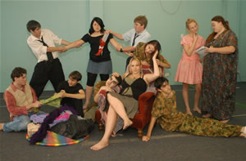
Cassie’s involvement with La Luna has provided her with the opportunity to not just be “in” community but “of” community. Cassie is loved by those around her. Not in a paternalistic way but loved for who she is. A young woman who enjoys the opportunity to be in the presence of other young women and men, who share a common “community of interest” – the theatre.
Cassie has played many roles over the years within the theatre company, roles that have contributed to its success.
Arminelle Fleming, Program Manager for the La Luna Youth Arts program, further reinforces this: “Theatre and films are important because they play the dual role of reflecting society while having the power to influence and effect change. Cassie’s involvement with La Luna Youth Arts has done just this – accurately reflected the diversity of young people in our community and challenged audiences to question their perception of individuals with a disability, and indeed young people in general.”
Cassie has not just brought her love of the theatre but knows that she is a good listener, a good teacher and a good friend.

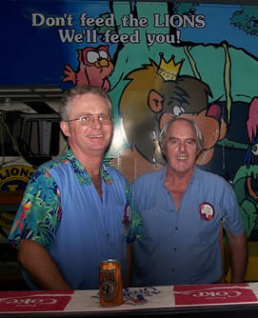
Ron's Story
Over recent years Ron’s memory has not been as good as he would like it to be since his illness 14 years ago. Despite this he has no problems at all when it comes to remembering Wednesdays. As Wednesday night is Lions Club night. Ron has been a member of the Castlehill Lions Club for the past 3 years.
Ron’s prior community participation was fairly limited. Restricted to a number of human services who along with his family provided on-going support and respite.
Ross, a Community Development Worker from Inclusion Works welcomed the opportunity to support Ron to achieve greater involvement within his community.
The Lions Club offered Ron what he was seeking, this being membership to a world wide organisation, companionship, a regular commitment, a great meal and the reason to share a drink, people to have a joke with, something to look forward to, an opportunity to contribute to the community and an excuse to dress up.
The interesting thing was that Ron has what the Castlehill Lions Club was looking for – commitment and loyalty, a strong sense of community service, a willingness to get along with others, a great sense of humor and unique life history that has taught others he comes in contact with.
Peter Heilbronn, President acknowledges that as with all members Ron has brought to the club a variety of gifts, talents and contributions that in turn has made the club a better club. In fact “when Ron arrives he brings with him a spirit and an energy that has an immediate impact on all who are present. You can’t ask for more from a member than that”.

Belinda's Story
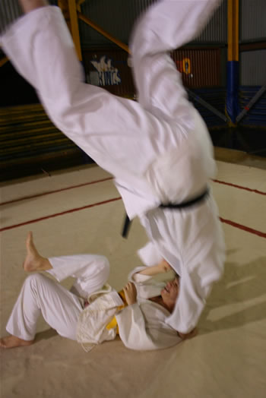
Belinda hasn’t always been throwing her weight around, but she does now. In fact, every Thursday night at the Castle Hill PCYC, Belinda joins with others from the Japanese Martial Arts KiseiDo Club and stands at the edge of the mat, waiting, with a sense of anticipation, fear and excitement. Belinda can hear her heart pounding in her ears. Belinda is ready.
She awaits for the call - “Hajime”.
Belinda was first introduced to the club by Kerri, a Community Development Worker from Inclusion Works in 2002. Belinda’s involvement was initially motivated by Kerri’s encouragement for Belinda to become stronger, both physically and mentally. Belinda has certainly achieved that over the years. Belinda’s visual impairment has not deterred her or the club from giving it everything they have. In fact judo is one of the few Olympic sports that a person with a visual impairment can participate on an equal basis.

Belinda believes that being on a judo mat gives her one of those rare moments where her disability is left outside of the mat. KiseiDo offers Belinda more than the opportunity to just get fit, but provides a welcomed balance to her daily commitments as well as provides a fantastic opportunity to be with a fantastic group of people who all share the same interest. Kiseido helps in forming a common-unity.
It is not just Belinda who has gained so much from the experience but the club itself.
John Moll, the Coordinator emphasised that the club has gained so much through Belinda’s involvement. He went on to say: “You know when Belinda first came to us she was timid, hesitant, and uncertain about her commitment to our sport. Now here we are 3 years later in the presence of a young woman who brings with her all the qualities that go with being a great member – dedication, enthusiasm, commitment, skill, achievement, a willingness to have a go, a laugh, a smile and above all her unique self. We can only be a better club when these qualities are around us”.

Rick's Story

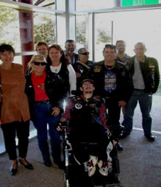
Over time Rick had lost contact with the wider community due to his ill health. He remained vibrant, fuelled by his one true passion, Harley Davidson (H.D.) Motorcycles.
Inclusion Works and Rick worked together to form links with the local H.D. Chapter to discover how Rick could become a member.
Rick enjoyed all aspects of Chapter life. Members of the Chapter became familiar with Rick’s form of communication and some of his physical disability needs, each helping to make his membership a reality. The club committee and members were sensitive to the obstacles of his membership and were willing to be educated. The true indication was in their openness to share what they all had, riding, owning and talking about all things Harley.
Rick attended club meetings, pub nights, State Rallies and could be found each Saturday morning surrounded by mates at the counter of the local H. D. Dealership. Rick’s health improved and his attitude changed simply because he now had the prospect of a future. Rick enjoyed three years of full participation with his mates before he sadly passed away. The local H.D. Chapter became a better Chapter owing to the unique gifts, talents and contributions that Rick brought to it.

